Collaborative Project - 2023 - The Nameless Pebbles

End-User Survey - Data Analysis Report - Monochrome

Updated: 28 Apr 2023

Prepared by Alexandra Connolly

# Overview

The purpose of this document is to analyse the data gathered from the survey provided to participants of our user testing sessions on Monday, April 24th 2023, and Wednesday, April 26th 2023.

## Methodology + Scope

The in-person user testing was carried out between 2 sessions provided to the team by Mr. Enda Finn during his scheduled classes with second year Games Development students and first year Augmented/Virtual Reality students. This convenience testing resulted in a confounding variable in the case of the Games Development students, in that their expectations would have been set quite high, and they would have an eye for bugs or performance issues due to the amount of experience they have with videogames. The opposite could be counted as a confounding variable for the Augmented/Virtual Reality students - their lack of experience could result in them knowing very little about the kinds of things they should be looking for during a videogame user test.

Our game was tested by a total of 9 participants, with 7 being male and 2 being female and a majority being between the ages of 16 and 20 - 2 participants were between 21 and 25. Participants were provided with the game via a USB that they could use to copy the game onto their device. Participants were given a brief explanation of the goal of the game and were then left to work their way through the game. Any time a user tester looked particularly lost or had ran into a bug/issue, team members were on hand to help. Once the testers had exhausted as many aspects of the game as they could, they were provided with the survey that they then answered before the end of the sessions. This resulted in players interacting with the game for different amounts of time.

The survey used during the user testing can be found [here](https://docs.google.com/forms/d/1TIJGa7Eqc-tEZcHzxzk2saF1AWeMl77JYYTAN6Y61Ew/edit). The survey consists mostly of likert scale and text box-type questions, with some questions looking for testers to choose from a range of multiple options. Bias could have possibly been introduced through a number of team members openly admitting that some features didn’t work and that some key objects were missing as testers were making open comments on their experience - this should have been avoided and team members should only comment on the game when testers are stuck or need help progressing.

## Findings

**QQ-Plots**

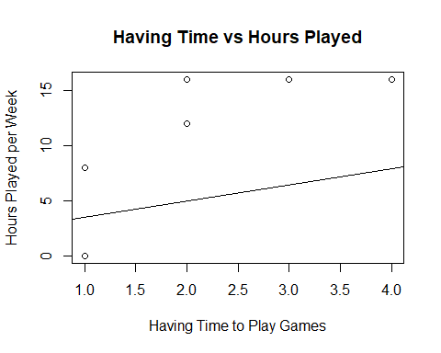

The QQ-plot shown above depicts participants’ agreement with the statement that they have time to play games during the college year, in relation to the amount of time they spend playing videogames per week (values taken from the lower end of each range), with some participants having the same answers for both questions. This QQ-plot is not normally distributed, which could be helped had the team been able to test with a larger sample of user testers that have a number of different levels of gaming experience. For now, the bias in this graph comes from the majority of testers having very frequent hours in videogames and therefore a lot of experience with videogames.

As we can see from the following histogram depicting answers to the same question, the data is unimodal and is skewed to the left, depicting that the majority of our participants have plenty of time to play videogames during the college year and so would be more experienced when it comes to user testing a game.The boxplot also shows this result, with a mean of ( = 2.3333333) and a standard deviation of (2.3333333).

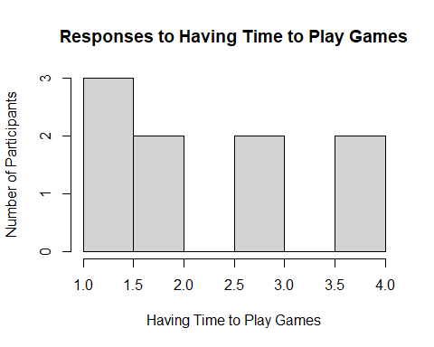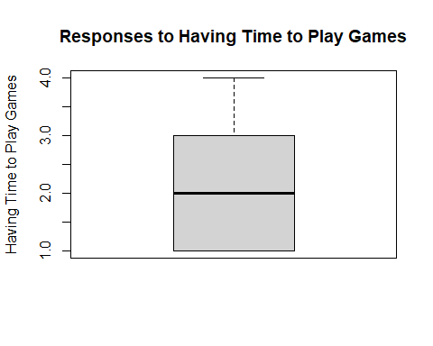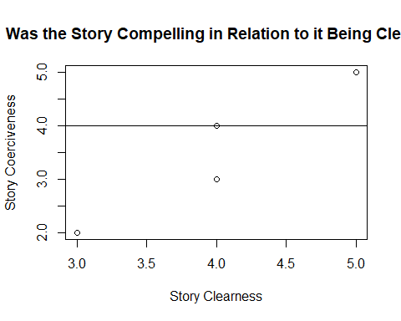

This QQ-plot shows how clear and emotionally compelling our game’s story was according to each user tester. This data is more normally distributed than the previous graph - only some points are along the determined line of normal distribution - and this would be further normally distributed had more user testing been done and more participants took part in our survey. The data is, once again, unimodal, and, for the most part, appears to not be radically skewed - most points fall within middle values on the graph, showing that most participants thought the game had an average story overall.

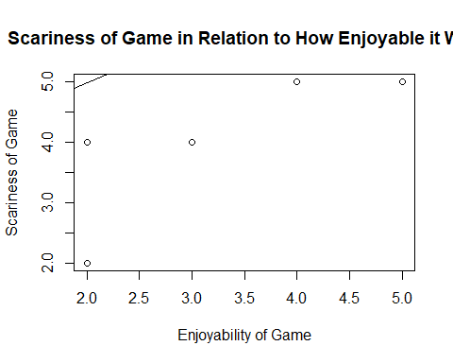

This QQ-plot shows how enjoyable participants thought our game was in relation to how scary they thought it was. The residuals are quite vast, so the graph as a whole is not normally distributed, but this graph is also unimodal and, while the enjoyability of the game is not incredibly skewed in either direction, the scariness is skewed to the right, showing that most players did not find our game terribly scary whatsoever. This is backed up by the fact that many participants had a hard time encountering the scary elements of the game and the ones that didn’t were unable to identify what those elements actually were.

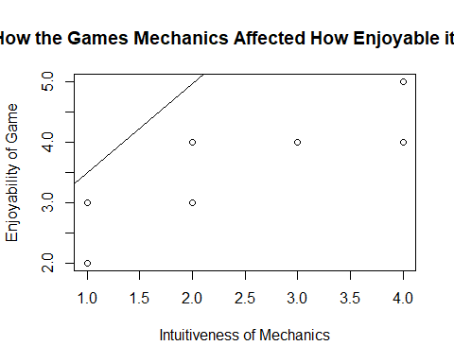

The final QQ-plot depicts how the mechanics impacted how enjoyable our game was for participants to play, in terms of how intuitive the mechanics are. The graph shows very large residuals and so shows a lack of normal distribution, and the data is unimodal once again. The histograms below show that the intuitiveness of our mechanics are slightly skewed to the right, indicating that most user testers thought our mechanics were straightforward, and our game’s enjoyability is not very skewed at all.

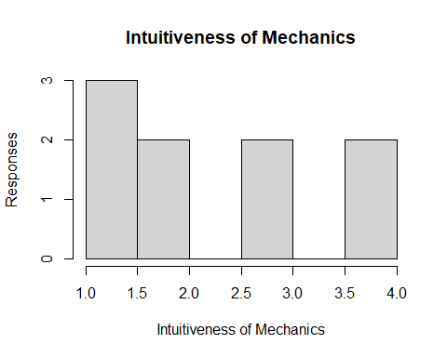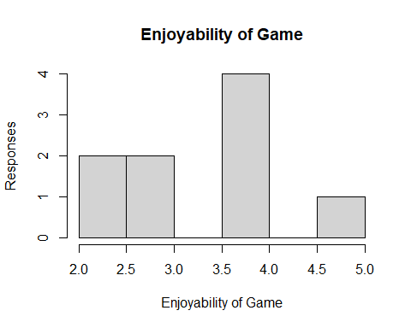

**Comparisons**

When it comes to what kinds of gamers liked our game’s story, user testers that liked adventure games seemed like the best fit to judge the coerciveness of our story, as adventure games tend to be most likely out of our included options to have a constant story running through the game. Of our 9 user testers, 8 testers said that they liked adventure games. To show this correlation, it was a simple matter of removing the coerciveness score given by the tester that did not select adventure games as a genre they enjoy playing. The following histogram shows specifically what adventure game players thought of our game’s story in terms of how emotionally compelling it was.

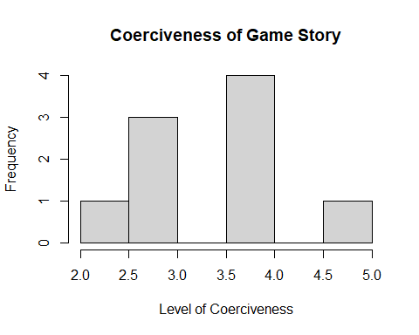

From the graph, we can see a mean of 3.5 and a standard deviation of 1.069045. This shows that videogame players that particularly enjoy adventure games thought our games story was average in relation to the likert scale used in the question, and that it wasn’t amazing enough to evoke much emotional investment.

Another comparison that can be made is the emotions felt by players during the game and how enjoyable the game was, as a game that can make one feel is one that would immerse players in the game’s setting, thus making it enjoyable. When it comes to the emotions felt during the game, most players claimed to not feel many of the emotions laid out in the question, the majority even claiming they felt none of them. This means the game fails to be compelling or to evoke emotions with this particular sample of user testers.

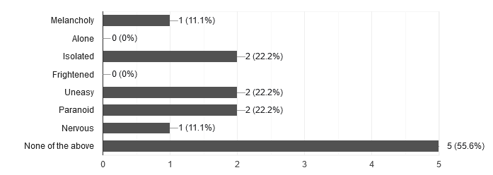

Alongside this, we can see how the testers that didn’t feel any of the outlined emotions enjoyed the game.

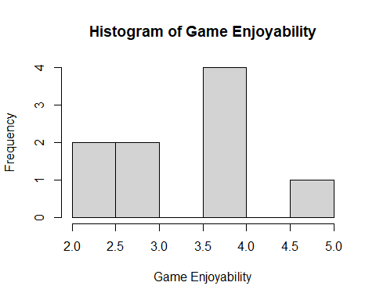

We can see that the histogram is bimodal, with a mean of 3.8 and a standard deviation of 1.0954451. This graph shows that those that didn’t have any particular emotions while playing our game did not find the game incredibly enjoyable as a whole, and is leaning more towards the game not being enjoyable at all.

## Conclusion

The survey revealed an average mean enjoyability ( = 3.4444444) and a very low mean scariness ( = 4.3333333) in relation to our game. This shows that, despite setting out to specifically create a scary game that was enjoyable for players, the team was unable to accomplish either of these things, according to our sample of user testers. The detailed findings show that the story of the game was not incredibly compelling to our testers, and that, despite most testers having a good amount of time dedicated to playing and experiencing videogames and finding our mechanics to be intuitive, they found our story unclear and the game as a whole difficult to properly enjoy. Some crucial feedback from the survey included points like character movement being improved and clunkiness removed, camera systems being changed to first-person, interacting with props around the environment like instruments, better differentiation between important and non-important props and lights be darkened in the environment to add to the ambience. With all of these changes and other recommendations being implemented, we believe the game would end up being more enjoyable and ticking more of the boxes we started this project with.