**$verywhereist**

**Printworks London**

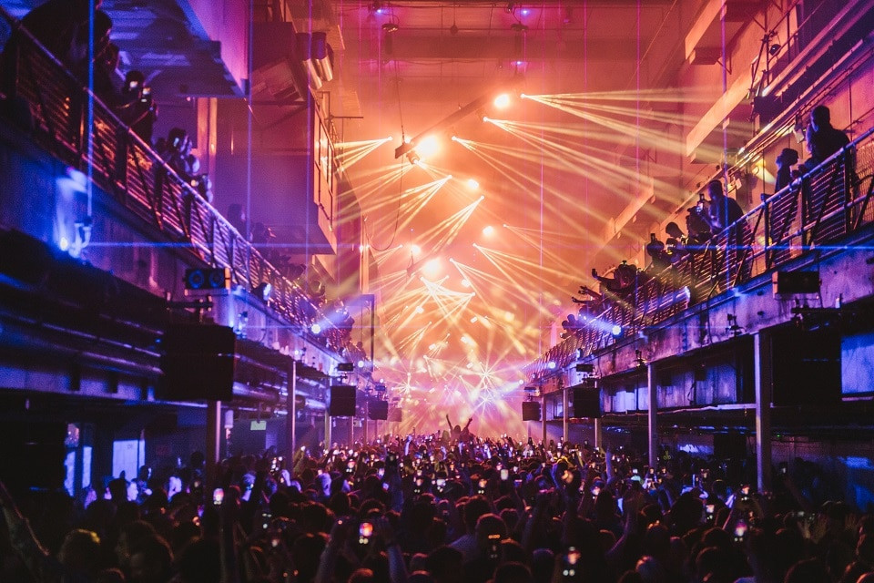

**Nightclubs in London**

**Printworks**

This iconic venue opened in 2017 and can hold up to 6,000 people and it has hosted some of the hottest DJs across the world such as bicep, defecated and Peggy gou.

The venue is known for its humongous size and excellent programming that attracts ravers from all across the globe.

Print works is all bout the techno and electronic music.

Tickets will vary from 22 pounds to 40 pounds which is a bit more on the pricey side for a nightclub but it is an amazing experience and a lot better then your usual nightclub. It also has some of the top DJs in the world which also plays a part in the price.

Print works has since closed down but it was honestly a great experience with friends and they have another one in Manchester which is currently open for everyone especially ravers to enjoy.

London is definitely one of the best places for clubbing way better then Ireland as there nightclubs are a lot bigger, more variety of different types of music and just overall more entertaining for young adults like me and my friends.

**Anne frank’s house Amsterdam**

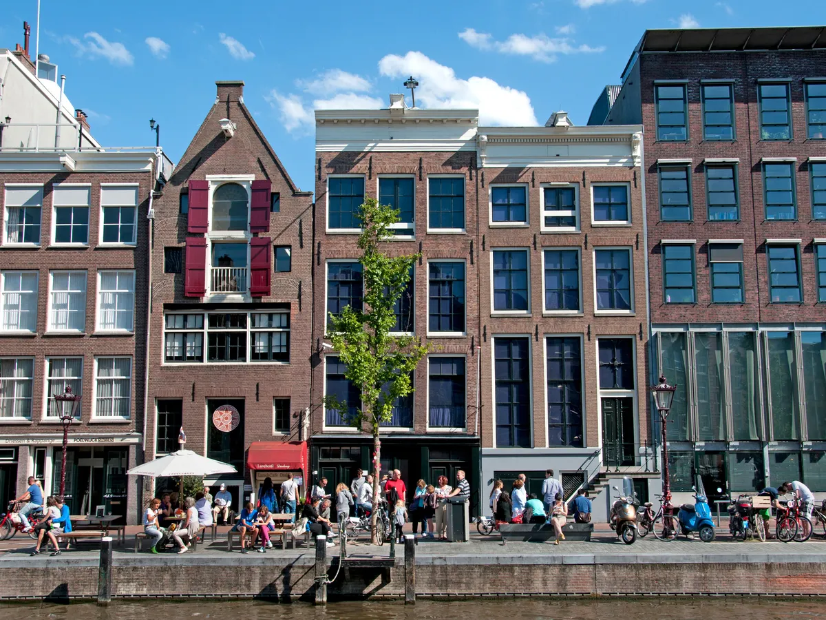

**Ann franks house**

**Amsterdam**

I visited this when I was in Amsterdam with my family, and it is a very good but emotional experience I would recommend everyone visits at least once.

You get a headset on arrival, and it talks you through the whole tour it is a very small space which gives an insight on what it was like to be these people living back in these times and how they must have felt especially not being able to leave when you want.

It takes around an hour to complete the tour and tickets cost around 20 euro, but they sell out very fast and you have to book in advance.

This experience was perfect for me and family because my dad is really interested in history and I was studying about this in history class in school at the time so it also helped me a lot in history class.

**Germany restaurants**

**German cuisine is a big part of Germany they are famous for;**

*“Delve into the world of*[***German cuisine***](https://www.expatica.com/de/lifestyle/food-drink/german-cuisine-261290/)*and you will soon discover an array of rich, hearty, and delicious dishes that are great comfort food as well. While each region of Germany has its own specialty dishes and traditional cuisine, there are certain culinary delights that people cherish throughout the country.*

*Because many of these are easy to make, you won’t find it too difficult to incorporate them into your weekly meal plan, either. So why not explore German culture with your tastebuds and create your own dishes using these* *handy recipes? Guten appetit!”(Expatica).*

* [Wurst](https://www.expatica.com/de/lifestyle/food-drink/best-german-foods-with-recipes-106759/#wurst)
* [Rouladen](https://www.expatica.com/de/lifestyle/food-drink/best-german-foods-with-recipes-106759/#rouladen)
* [Käsespätzle](https://www.expatica.com/de/lifestyle/food-drink/best-german-foods-with-recipes-106759/#kasespatzle)
* [Eintopf](https://www.expatica.com/de/lifestyle/food-drink/best-german-foods-with-recipes-106759/#eintopf)
* [Sauerbraten](https://www.expatica.com/de/lifestyle/food-drink/best-german-foods-with-recipes-106759/#sauerbraten)
* [Kartoffelpuffer](https://www.expatica.com/de/lifestyle/food-drink/best-german-foods-with-recipes-106759/#kartoffelpuffer)
* [Brezel](https://www.expatica.com/de/lifestyle/food-drink/best-german-foods-with-recipes-106759/#brezel)
* [Schnitzel](https://www.expatica.com/de/lifestyle/food-drink/best-german-foods-with-recipes-106759/#schnitzel)
* [Schwarzwälder Kirschtorte](https://www.expatica.com/de/lifestyle/food-drink/best-german-foods-with-recipes-106759/#schwarzwalderkirschtorte)

[The top 10 German foods – with recipes | Expatica](https://www.expatica.com/de/lifestyle/food-drink/best-german-foods-with-recipes-106759/)

This website is where I got information and inspiration for German food it also gave a list as shown above of foods that our most famous in Germany.

I have visited Germany twice and both times it was amazing especially the food the most recent time we went was in summer and we went to quiet a few restaurants which I really enjoyed my favourite was probably Italian even though that’s not very “German”.

The restaurant we ate at was located in berlin right on the square beside Hilton hotels where we were staying this was a little bit more on the expensive side as it was in a tourist populated area.

I ordered the burrata and pepperoni pizza and for dessert I had tiramisu, this was all unreal even my parent enjoyed it and they are very tough to please with food. I would definitely recommend all restaurants I went to in Germany, as they were all some of the best quality food I have ever had.

**Island hoping Canary Islands**

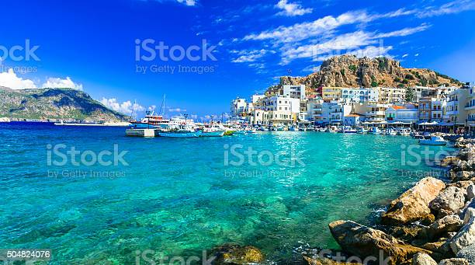

**Canary Islands Island hoping**

Island hoping in the canary islands is the perfect way to see the whole island and a lot of the island surrounding it. Some of the Canary Islands you can island hop too which I have done with my family and really enjoyed is Tenerife, gran Canarias, la Gomera, Fuerteventura, Lanzarote.

This a perfect opportunity too take pictures of the islands hop on and off the boat and explore other islands and also diving off the boat into the sea which isn’t for everyone but its really fun if you like the water.

Island hoping can last 3-5 hours which is not ideal if you get sea sick easy.

My friend went island hopping with us and got sick everywhere it was safe to say she did not enjoy this trip. But if you don’t mind being on a boat for a long time this is something you should defiantly consider as it is very beautiful.

**New York everything**



New York everything

I have never actually been to New York but I am making this one of blogs because I would love to visit here. New York at Christmas would be one of my dream holidays or anywhere with skiing or snow or good shopping as long as it has my type of whether shopping and good food I’m a happy camper.

Five things I would like to do when going to new York is

* Try New York bagels and pizza.
* Shopping, shopping and more shopping
* See the statue of liberty.
* Visit central park.
* Visit time square.

Being in New York for Christmas is my dream because of the movie home alone 2 where he is lost in New York and during the whole movie all you can see in the background during this whole movie is Christmas lights snow and massive outdoor Christmas trees. It is really just a winter wonder land and is perfect for me as I am obsessed with all things Christmas.

**Inspiration**

Everything Eva was my inspiration for this travel blog as she does a lot of similar travel blogs to the ones I did. She focuses in on specific countries and what she done while she was there her blogs are also very digital and easy to read which is very important for a blog, so I tried to take that on bored when creating my blogs.

I also really enjoyed reading her blogs about travel, I thought they were very interesting to read which also important when creating blogs because blogs can be quiet boring if not done correctly. Eva also has a great use of photos which I tired to include in my blogs as well.