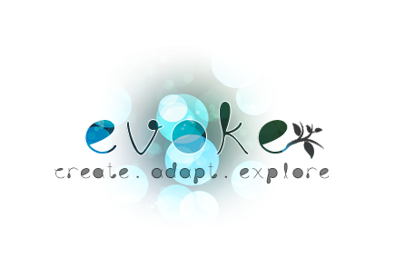

By evoke studios
12/12/2013

Michael Murphy  Sean McCooey  Nicholas Murray  Tadhg Deeney  Keith Byrne | Interface Programming  3D Modeller  Sound Engineer  Animator  Game Engine Programming

Contents
Game Overview 4
Common Questions 5
What is the game? 5
Why create this game? 5
Where does the game take place? 5
What’s different? 5
Feature Set 6
General Features 6
Social Features 6
Gameplay Features 6
Genre 6
Target Audience 6
Welfare theme 6
Seasonal Affective Disorder 6
The Game World 7
Overview 7
Adaptive World 7
Creating Worlds 7
Scaled Environments 7
Locations 8
Objects 8
Day and Night 8
Characters 9
Overview 9
Reasons for Third Person 9
Gameplay and Mechanics 10
Game Progression 10
Movement 10
Actions 10
Objects 11
Overview 11
Craft Orbs 11
Message Orbs 11
Treasure Orbs 12
Music and Sound Effects 13
Overview 13
Dynamic 13
Art Style 14
Peripherals 15
LEAP Motion Controller 15
Evoke Moodbar 15

Game Overview
Evoke is a third-person open world creative space. Fundamentally Evoke aims to encourage creativity and provide a space where the user can relax, socialise and most importantly, create & explore. Evoke will combine the use of Motion Controls, an external Light bar (Evoke Mood Bar) and social interaction into an experience that has never been achieved before within a game environment. We will use the fundamental principles of Light & Talk therapy to attempt to emulate the treatment of particular symptoms of SAD, Such as lack of enjoyment, difficulty concentrating and less time spent socializing.
The idea of Evoke is to alter a world in any way you wish, then explore your space as it evolves over time. Floating above your world are Orbs, Orbs can contain an array of elements from terrain to treasure. As you collect the orbs and drop them to the globes surface the element contained within the orb is brought to life right before you. Create vast deserts or forests or even combine the orbs for something truly unique. No two experiences in Evoke will be the same.
Control your character by hovering your hands in front of your computer and simply sway in your desired direction thanks to the Leap Motion controller. Watch as the Evoke Mood bar illuminates your real life surroundings in reaction to your creativity in game. All this while you explore your evolving ecosystem opening messages from friends and family contained within Message Orbs hidden throughout the world. Evoke prides itself on the depth of creation, unique animals, environments and gameplay all displayed in a distinctive art style will immerse the user and encourage them to, Create, Adapt & Explore.

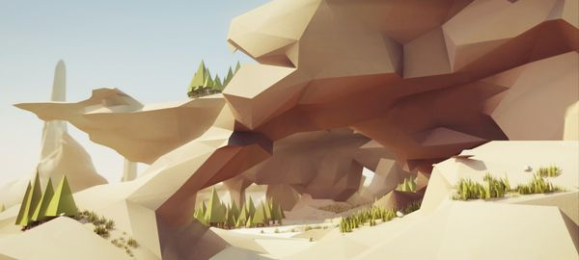

Common Questions

What is the game?
Evoke is a third person sandbox adventure that encourages the player to explore a creatively mysterious world and reach out to those who are close to them.

Why create this game?
We wish to create a game that can be used to set aside twenty-thirty minutes out of your day and relax. We invite the player to get lost in a world full of uplifting scores, beautiful scenery and engaging gameplay to allow them to relax and take the time to remember what is important in their lives.
Where does the game take place?
The game takes place in a dream world where you, the player, are encouraged to explore and adapt the world to your choosing. Your avatar will allow you to dynamically customize the terrain, fauna, flora and colour within this fantasy world.
What’s different?
The player has complete control over their environment and has a major impact on the growth of the world. The Moodbar is used to inform the player of their use of colours within the game and provide feedback on their movements. Twitter integration will allow friends and family to send messages to their loved ones (The player) and invoke happiness and nostalgia from those they haven’t talked to in a while.

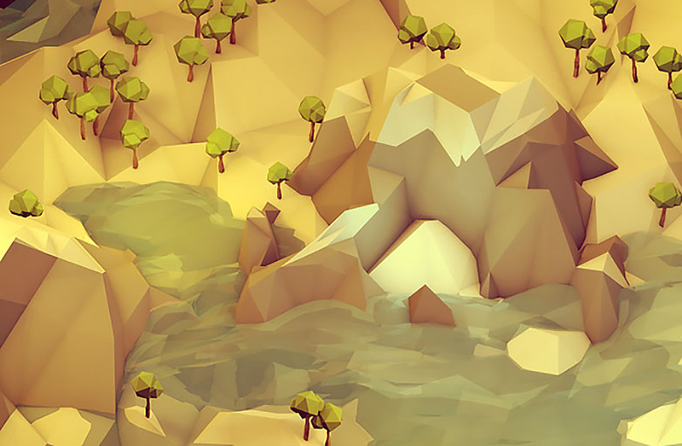

Feature Set

General Features
Sandbox
World Customization System
Social Experience
Evoke Mood Bar

Social Features
Twitter integration
Family Messages
Community statistics

Gameplay Features
Adaptive scenery
Drop orbs to create terrain
Flying character
Explore the world
Customize character
Collect orbs
Collect messages from loved ones

Genre
Third Person Sandbox Adventure

Target Audience
After much research into who our game could appeal to we have discovered that our game could be beneficial to and will be mainly aimed towards secondary school students (12-18 year olds).
This research has been in relation to SAD, technology access, use of social networks and playing games of similar genre.

Welfare theme

Seasonal Affective Disorder
Seasonal Affective Disorder is a type of depression that usually effects people in either the winter or summer. It is quite common in some countries namely Finland, were 9.5% of the population is affected by SAD. Many believe that SAD is the reason behind the high number of suicides seen in Finland. Light therapy is used in many cases to help with SAD. Light therapy sessions involve sitting in front of a light box or SAD light for a period of time. This treatment has been worked into our game using colour psychology and the evoke Moodbar.

The Game World

Overview
In evoke the game world is a template for players to create their dream home. As the game adapts to their choices the world begins to change. Each player is given a unique environment to begin with which offers a few landmarks such as forests or monuments. The world is completely adaptable. The player alters the world by dropping orbs in the gridded areas. User can create anything from rainforest worlds to oceanic worlds.

Adaptive World
The sky will adapt to the player’s needs it will take notice of the primary colours that the player is choosing and begin to show more of these colours. In particular the sky and the evoke bar. We can use the Evoke bar to relay the warm seasonal colours from the forests or calming blue from the ocean. This will help immerse the user and reduce the effects of seasonal affective disorder.

Creating Worlds
We plan to make this possible by using a grid based system. The world will have a basic initial layout based on the calibration process. As the player learns the mechanics, they can alter the grids attributes using orbs with particular symbols. For example a desert area on the grid can be changed to grass by dropping an orb a grass symbol onto the area. This allows the player to customize the planet in any way they see fit. Orbs can be combined and used on top of each other to achieve interesting results.

Scaled Environments
To allow for the unique gameplay we want to achieve we must adjust the scaling of objects relative to each other. To put this in perspective, the world to player ratio will be like that of a Lego man to a beach ball. This will allow the player to quickly navigate the world they have created and yet is big enough to allow for a vast number of possibilities. The objects that will be placed in the world, will also be quite big in size relative to the world. The player can choose to scale these objects even more if they wish.

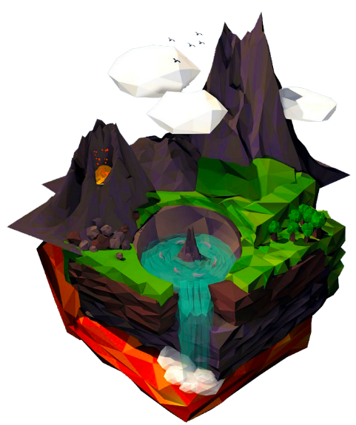

Locations
The player will be given one of a number of predetermined worlds to begin with. Players will then be able to create a number of different biomes. Such as dense forests, hot deserts, and cold snow terrain. The player may change the environment at any time by picking up different orbs and changing the terrain.

Objects
The objects in the world will be scattered around the world, some floating in plain sight other more unique ones hidden from the player. This objects will mostly take the form of various orbs. These orbs are used by the player to change their world. Some unique orbs will contain messages from outside sources such as family. These messages will be communicated to the game from Twitter.

Day and Night
The game will go through a 24h Day/Night system similar to Earth but with an in game hour being represented by a real world minute. At night the orbs would glow brightly in the night sky. The night could affect the biomes in different ways allowing for more interesting gameplay mechanics.

Figure 1: Concept

Characters

Overview
The main character of evoke is a cloaked female humanoid. The characters will express different emotions throughout gameplay on its face and through its body language. The player will be able to invoke this creature to travel across the landscapes and alter the terrain as they see fit. This allows them to have complete control of what is created in their world. The avatar will be dynamically customizable, as you will be able to pick up different cloaks and change them at will.

Reasons for Third Person
We decided on a third person avatar rather than first person because we wanted express how important body language and facial expressions are to the player. Approximately 80% of communication is non-verbal and we hope to encourage the player to go out and recognize these movements when in social situations.

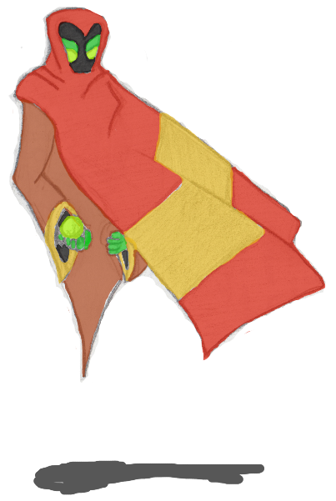

Gameplay and Mechanics

Game Progression
Owing to the games freeform nature it won’t have any set beginning or end. Although they will be able to collect treasure orbs hidden throughout the world to unlock unique craft orbs and cloaks.

Movement
The player will fly around the world and as such have 360 degrees of movement. They will have full control of their speed and will be able to stop and float at any time they wish. The only times their movement will be constrained will be at cloud and ground levels. They won’t be able to land or to travel up into space.

Actions
As the emphasis of the game is on providing a simple system for the player to obtain complicated results there will be few actions. They can move, pickup and drop. Pickup will be context related based on the type of orb involved. A craft orb will be added to the player’s inventory, a message orb will display its contents and a treasure orb will be collected. Drop will allow them to place a craft orb into the world where they want it.
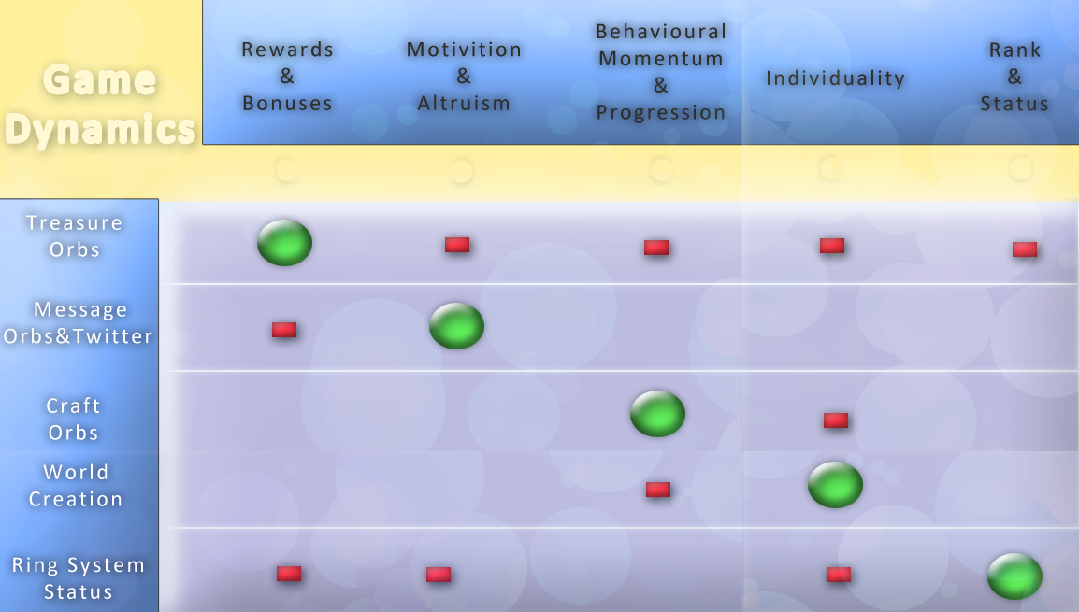

Objects

Overview
We tried to keep the game mechanics of evoke as simple as possible so the actions have limited and combined for ease of use. The player interacts with the game using various different types of orbs. Each class of orb will be designed differently so that players will be easily able to tell them apart. Each orb will be scattered around the world, some hidden, and others plainly in sight for the player. Over the course of the game the player may see different variances of the orbs appear. Each class of orb has a number of different subsets with will perform different actions, these will be distinguished by colour and symbol.

Craft Orbs
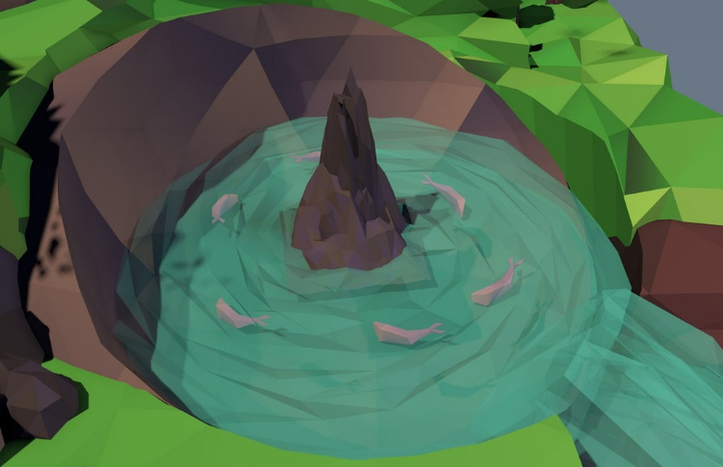
Craft orbs allow players to creatively change the world. When the player comes into contact with a craft orb he/she picks it up. The player is allowed to carry up to three craft orbs at any single time. They can switch between them and choose the orb they want. When a craft orb is dropped onto the world the players world adapts to the new design. This gives players almost unlimited freedom, allowing them to creative whatever world they want.
Planet split into a grid. Each grid space has 5 slots. Each of these slots hold a different element that collectively layers together to form the terrain. The different layers are:
- Terrain – Up (Mountains), Down (Valleys)
- Content – Fertile (More plants), Barren (Less plants), Liquid
- Colour – Red, Green, Blue, etc.
- Temperature – Hot (Sun), Neutral (Rain), Cold (Snow)
- Special – Unique elements gained from treasure orbs (Lighthouse)
First orb of a type dropped onto a grid changes the element with each successive orb altering the amplitude. For example if a space was currently “barren” and a fertile orb was dropped onto it, the space would be changed to fertile with each additional fertile orb creating more/larger plants.

Message Orbs

Message orbs allow for communication between the player and the outside world. Message orbs will hold written messages received from family or friends. These messages will be sent into the game using the Twitter. The hope is, is that these messages will personalise their world even more and encourage the player to add a social element to their lives if they are suffering from depression. These messages orbs will take the shape of a typical sphere shaped orb. The colour of the orb is up to the sender of the orb.
Figure 4 - Message orb: Text

Treasure Orbs

Treasure orbs will act as the typical collectable, however they serve an important function. These orbs will be very rare and be hidden well throughout the player’s world. Treasure orbs will unlock new unique craft orbs and cloaks to enhance the player’s experience. Collecting these orbs are not integral to the game, however the hope is, is that players will enjoy exploring the vast worlds they have created hoping to find out what the hidden treasures hold. Treasure orbs will be instantly recognisable: they will be clusters of bright moving orbs.
Figure 5: Treasure orb

Music and Sound Effects

Overview
The music and sound effects in Evoke will play an important part of the overall experience of the game. We hope to develop a simple dynamic sound engine which will generate ambient environmental sound effects throughout the game world to further immerse the player in the gameplay and to help with the relaxing atmosphere we want to create within the gameplay.

Dynamic
Original sound effects and music will be created using Pro Tools, for any pre-recorded sounds we wish to implement. For the dynamic environmental sound effects we will implement the use of Pure Data into the Unity engine which will generate different sounds which will be dependent on how the player moves, where the player moves and other variables such a speed and momentum of the games characters. A dynamic chime will be generated on collection of different types of orbs in the game. Instrumentation is yet to be chosen for the games soundtrack, but in general, string instruments such a violins and harps can be related to a very relaxing musical experience and other operatic instruments to create an uplifting and inspiring musical score

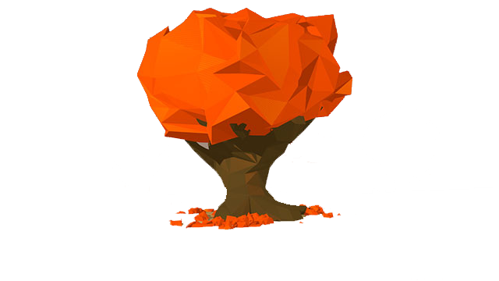
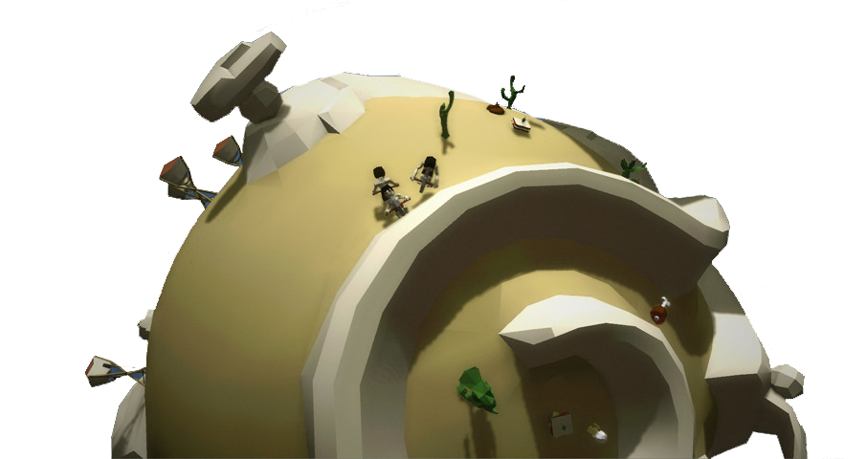

Art Style
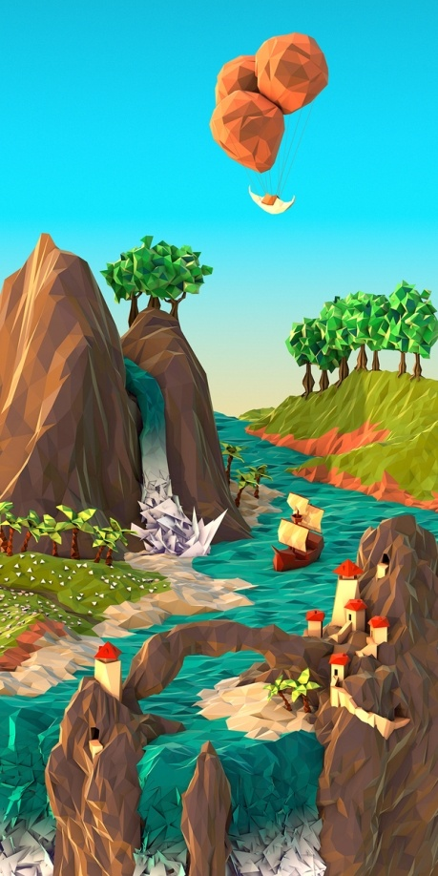
We have decided to use a polygonal art style as its use of simple form to create complex and beautiful images fits directly with the idea of our game as a whole.
Using a low poly design attribute, we feel like the world will be able to envelope a simplistic, colourful style that will be entertaining and engaging for the player to return to the game and spend time sculpting and forging their very own planet/world.

Peripherals

LEAP Motion Controller
Evoke will use the LEAP Motion Controller to immerse the player in creating their own world. Studies have shown that people enjoy using their hands to create things. We hope that the LEAP will give the same effect but in a digital world. It also opens the game up to different generations and markets, from people that may not be able to grasp a typical controller to people that have a hard time remembering what actions belong to different buttons.

Evoke Moodbar
The evoke Moodbar will be designed and programmed by us. It will relay the colours in the game to the player using real world lights. This will work much like Sony’s new Dualshock 4, with its Moodbar on the back of the controller. The Moodbar is designed to help players affected with SAD and hopefully will work as a SAD light.

